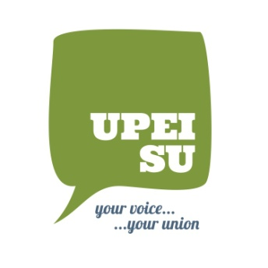
UPEI Student Union
Job Description

Job Title: The Cadre Managing Editors
Reports to: The Cadre Editor-in-Chief
Position Type: Student Staff (Must be a full time student)
Work Location: WA Murphy Student Centre
Start Date: September 2nd, 2020
Compensation: As per the UPEISU budget upon approval

The Cadre Managing Editors are responsible for researching and writing articles regarding current events.

Responsibilities include:
  - Attend weekly staff meetings;
  - Contribute news ideas;
  - Research and write news articles as assigned;
  - Edit articles submitted by volunteers;
  - Take pictures or develop graphics to accompany article

Qualifications & Skills:
- Computer skills
- Strong interviewing and writing skills
- Editing skills

Deadline for application is 3:00pm on September 4th, 2020. To express interest in this role, please direct your application form, resume and class schedule in confidence to:

UPEI Student Union Hiring Committee via email: hiring@upeisu.ca or in person at the Student Union office.

Only applicants that have completed the application requirement will be considered for the position. Only those selected for an interview will be contacted.

